**Lesson 6 Demo 4**

**Ansible Conditionals**

|  |
| --- |
| **Objective:**To implement conditionals through playbooks    **Prerequisites:**You need to have one playbook to run the conditionals.  **Tools required:** Ansible |

**Steps to be followed:**

1. Running playbook containing conditionals
2. **Running playbook containing conditionals**
   1. Create a playbook file with the name **conditionals.yaml** using the below command:

**sudo nano conditionals.yaml**



* 1. The contents of the above file should be in the below format:

**---**

**- hosts: webservers**

**become: true**

**tasks:**

**- name: "Sample Message"**

**command: echo "Testing"**

**when: ansible_facts['os_family'] == "Ubuntu"**

* 1. For when statement:

tasks**:**

**-** name**:** "Testing Debian"

command**:** echo “Debian”

when**:** ansible_facts['os_family'] == "Debian"

* 1. For multiple conditions grouped together using “or” and “and” logical operator:

tasks**:**

**-** name**:** "Testing **either** CentOS6orDebian7systems"

command**:** echo “Either CentOS6 or Debian 7”

when**:** (ansible_facts['distribution'] == "CentOS" and ansible_facts['distribution_major_version'] == "6") or

(ansible_facts['distribution'] == "Debian" and ansible_facts['distribution_major_version'] == "7")

* 1. For multiple conditions with a logical “and”:

tasks**:**

**-** name**:** "TestingCentOS"

command**:** echo “CentOS”

when**:**

**-** ansible_facts['distribution'] == "CentOS"

**-** ansible_facts['distribution_major_version'] == "6"

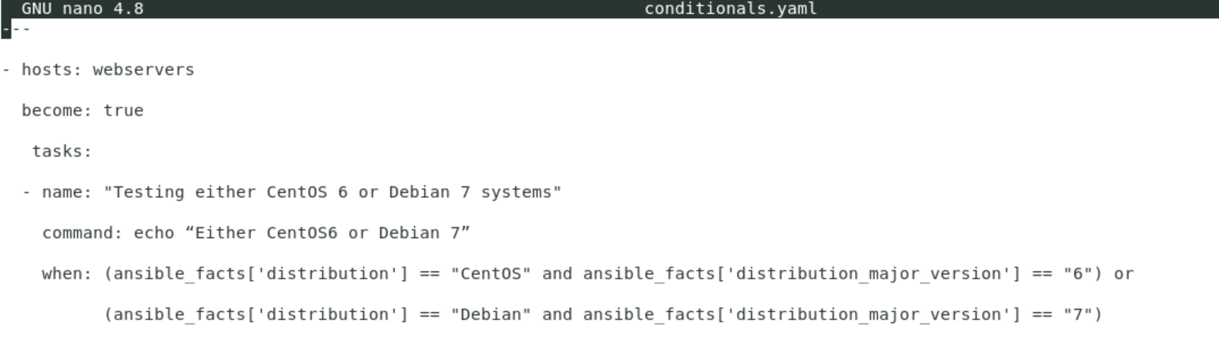

* 1. Run the below command to run the playbook:

**ansible-playbook conditionals.yaml**

